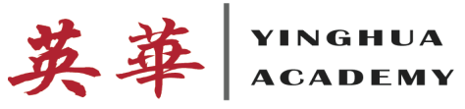

Dear Parents/Caregivers,

One of our goals at Yinghua Academy is to help the children realize the joy of reading. The only way to get better at reading is to read on a regular basis through books, comics, magazines, and newspapers. A program that we are participating in will help get your child motivated to read. That program is BOOK IT!. BOOK IT! is a program whose goal is to turn children who read because they have to into kids who read because they want to.

Through Book IT!, your child has the opportunity to earn award certificates by meeting their monthly reading goals that are set at Yinghua Academy. By earning an award certificate through BOOK IT!, your child can use them at a Pizza Hut location to receive a free personal pizza. There is no purchase necessary and the pizza can be taken to go.

On the first visit, your child will also receive an official BOOK IT! Passport to Reading and a sticker to track their reading progress throughout the program months. On subsequent visits, they will get another free pizza and sticker to add to their passport.

The Book Program will begin on October 1st. The goal for the first month for the 2nd and 3rd grade students is to complete the attached calendar by coloring in the days that they read at least 20 minutes a day, five days a week, Monday through Friday. They must complete two book reviews. Your child will return the packet on November 1st and receive their first pizza certificate. The next goal will be set on November 1. This program will continue until March 31, 2015.

For more information on the Book It! Program, go to the website at www.readyourheartout.com. A free mobile app is available to help your child on his/her reading progress.

Sincerely,

Ade Alabi
2nd/3rd Grade English Language Arts

