Parking Updates for Grandparents’ Day GUESTS on Thursday, October 2, 2014

Please allow extra time for parking. Curbside drop-off is available at Yinghua’s main entrance, 1616 Buchanan Street NE, Minneapolis, 55413. Please contact event co-chair Abigail Pribbenow if you have concerns about access: pribbena@augsburg.edu or 612-812-0602.

Yinghua has reserved a Minneapolis Park & Recreation Board parking lot for school use on October 2; however, this lot, which serves Jim Lupient Water Park, is four blocks from the school’s main entrance. You may access this lot off of Johnson Street NE.

To get to the Jim Lupient parking lot from the main entrance to Yinghua, take a right on 18th Street NE, right at the Johnson Street NE stoplight, right at the stoplight opposite The Quarry shopping center (to continue on Johnson Street NE), and right into the parking lot. See the map below.

If a four-block walk is too far, we suggest you search for parking in the following places:

1/The Yinghua Academy staff parking lot on Pierce Street NE near the tennis courts.

2/Street parking on close-by Pierce and Buchanan Streets NE and 16th Avenue NE, or on slightly more distant Lincoln and Fillmore Streets NE.

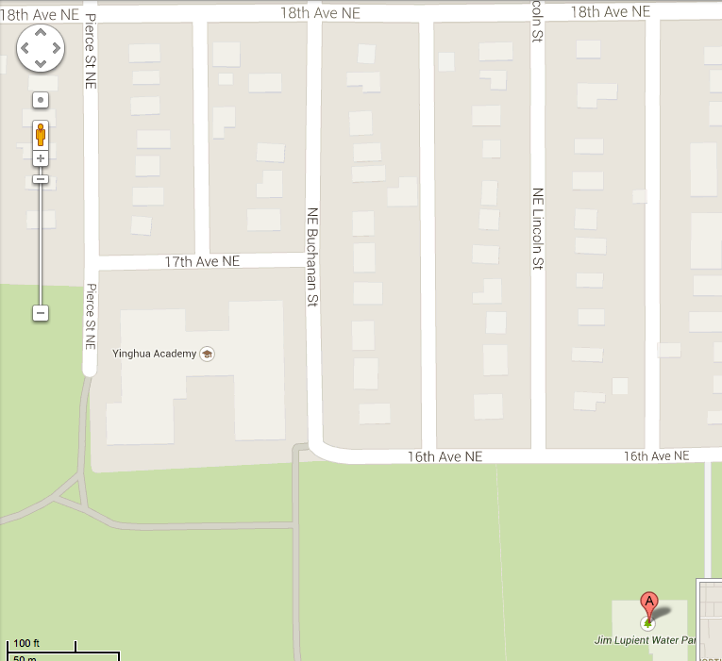

Parking Updates for Staff and Volunteers on October 2, 2014

Yinghua Academy STAFF and October 2 VOLUNTEERS, allow extra time for parking on October 2. Please park in the Jim Lupient Water Park lot, and fill the most distant spots first. Please help us leave the staff parking lot on Pierce Street as well as close-by street parking spots as open as possible for Grandparents’ Day GUESTS.

