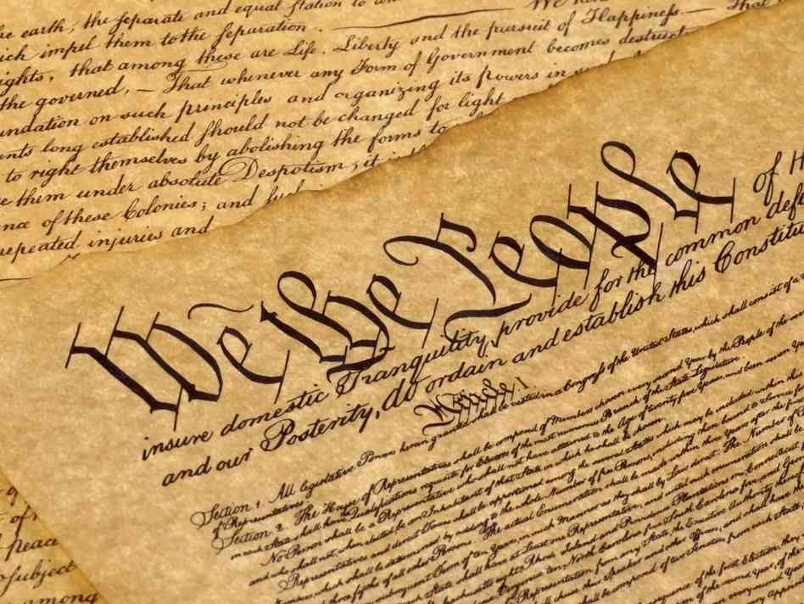 Debate preparation : Persuade your colleagues!
http://media.npr.org/assets/img/2010/10/25/constitution-3a6e5d963ceee4f7cd7ef448cb32e5ee8e86f7e0-s6-c30.jpg

My name is ___________________ and I represent the great state of __________________________.
My esteemed colleague from ______ suggests that __________...

We all believe___________ …

On behalf of my state, _______, I respectfully agree/disagree. I believe that _______ …

http://janeaustensworld.files.wordpress.com/2011/11/quilhand.jpg
I ask for your support.

