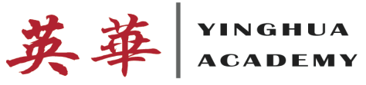
Parents/Caregivers,
The only way to get better at reading is to do it. So, with the help of the BOOK IT! Program, the English classes at Yinghua Academy will be “reading our hearts out” for the next six months. The BOOK IT! Program is all about turning kids who read because they have to into kids who read because they want to.
Through BOOK IT!, your child has the opportunity to earn reading award certificates by meeting monthly goals that we will set at school. The certificate can be redeemed at Pizza Hut where your child will receive their very own free personal pizza to celebrate their reading accomplishment. There is no purchase necessary and the pizza can be taken to go.
On their first visit, they will also receive an official BOOK IT! Passport to Reading and sticker to track their reading progress throughout the program months. On subsequent visits, they will get another free pizza and sticker to add to their passport.
You can find out more about BOOK IT! by going to www.readyourheartout.com. A free mobile app is also available to help your child on his/her reading progress.
The first goal for grades 4/5 is to complete the attached calendar by coloring in the days that your child reads for at least 20 minutes (5 days/week) and completing 2 book reviews. Your child will return the packet on November 1st and will receive their pizza certificate. The next goal will be set on November 1st as well.
Together, we can raise a reader!
Regards,
Jenna Padilla
Grades 4/5 English Language Arts

