Grade 4 Spelling – May 2-8
I am making a change in spelling quizzes for Term 3. Students will only be tested on 10 words. In addition to these ten words, students will be assigned each Friday spelling activities and a quiz through the Minnesota State Assessments site. The students will need to complete the spelling activities online by the Thursday before they test on the ten words. The quiz completed online and the written spelling test will be combined together as one score for that week.
- Spelling for the week of May 2-8
- Online Assignment due on Wednesday, May 7
- Test is on Thursday, May 8
- You should practice writing the spelling words at least 3 times before the Thursday quiz.
Group 1 | Group 2
simple | absence
difficult | presence
smooth | abundant
rough | scarce
miniature | imitation
enormous | genuine
ancient | vacant
modern | occupied
silly | amateur
serious | professional

How to view your spelling assignment:
- Go to www.mnstateassessments.org

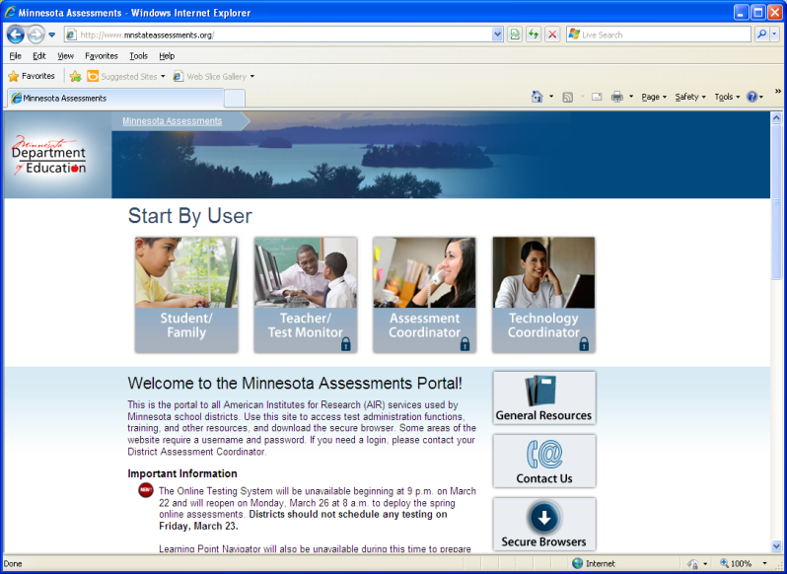

- Click on Student/Family
- Click on Learning Point Navigator
- Enter your information (first name, MARSS number, date of birth)
- Click on your spelling assignment

