My Native American Tribe Report-May 2014
Student Name: ______________________________________
Tribe’s Name: ____________________________________
- Use the below organizer to take notes on your Native American Tribe. You do not need complete sentences when taking notes.
- Write down the important information. Also write the source in which you got the information and page number(s).
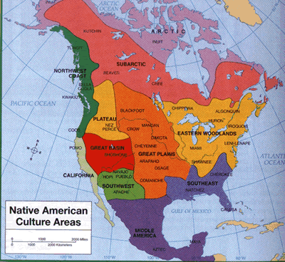

Introduction:
Source: ____________________________
Page(s): _____________________________

Region & Traditional Dwelling:
Source: ____________________________
Page(s): _____________________________

Traditional Clothing:
Source: ____________________________
Page(s): _____________________________

Food & Agriculture:
Source: ____________________________
Page(s): _____________________________

Transportation, Tools & Weapons:
Source: ____________________________
Page(s): _____________________________

Language, Religious Beliefs, Customs and Daily Life:
Source: ____________________________
Page(s): _____________________________

The Arts: Music, Art, Dancing, Sports:
Source: ____________________________
Page(s): _____________________________

Other interesting facts:
Source: ____________________________
Page(s): _____________________________

Conclusion:
Source: ____________________________
Page(s): _____________________________

