Grade 5 Spelling – March 24-28
I am making a change in spelling quizzes for Term 3. Students will only be tested on 10 words. In addition to these ten words, students will be assigned each Friday spelling activities and a quiz through the Minnesota State Assessments site. The students will need to complete the spelling activities online by the Thursday before they test on the ten words. The quiz completed online and the written spelling test will be combined together as one score for that week.
- Spelling for the week of March 24-March 28
- Online Assignment due on Thursday, March 27
- Test is on Friday, March 28
- You should practice writing the spelling words at least 3 times before the Friday quiz.
Group 1 | Group 2
aisle | eventuality
chemical | personality
conquer | neutrality
rehearse | originality
peculiar | hospitality
original | vitality
chorus | normality
ravine | brutality
hustle | generality
machinery | equality

How to view your spelling assignment:
- Go to www.mnstateassessments.org

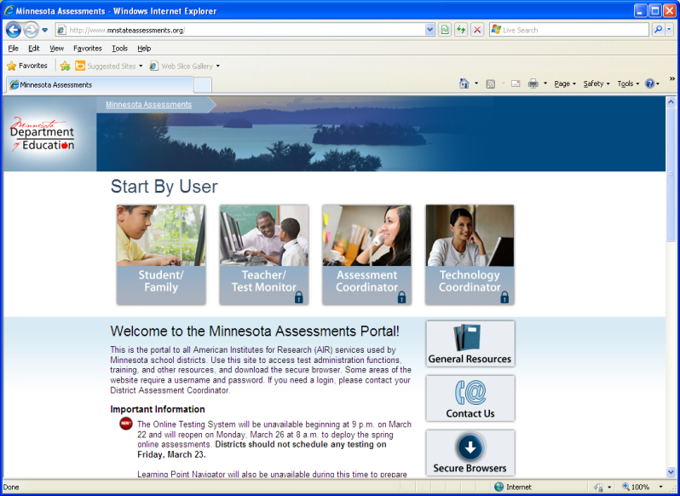

- Click on Student/Family
- Click on Learning Point Navigator
- Enter your information (first name, MARSS number, date of birth)
- Click on your spelling assignment

