Dear Grade 5 Parents,
In preparation for the MCA exams, I have created additional online assignments that your student will need to access online at home. These assignments are designed to help your student prepare for the upcoming MCA exams. Listed below are step by step directions on how to log onto mn state assessments. Students will need their MARSS number, which should be located inside their planner, in order to log on. Please email me if your student did not bring home their planner so I can email you their MARSS number.

How to view your assignments:
- Go to www.mnstateassessments.org

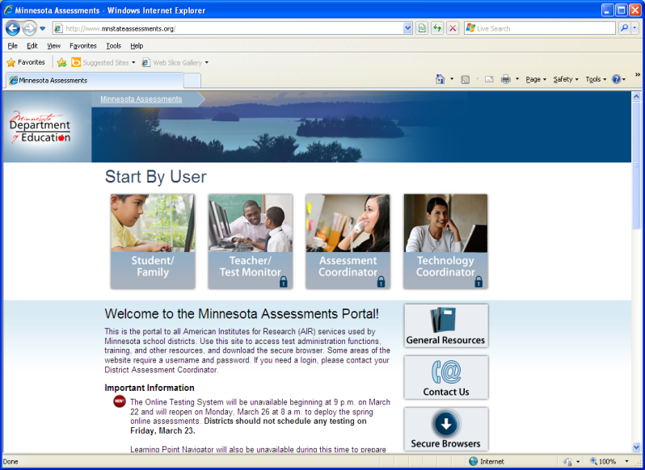

- Click on Student/Family
- Click on Learning Point Navigator
- Enter your information (first name, MARSS number, date of birth)
- Click on your assignments

Please have a parent sign and date in the box provided after you complete each assignment.

Assignment | Parent Signature | Date
Grade 5 Descriptive Language
Grade 5 Nouns/Pronouns
Grade 5 Root Words
Grade 5 Vocab in Context

Enjoy your break!

Sincerely,
Danielle Jesperson
Danielle.jesperson@yinghuaacademy.org

